Nombre _______________________ Fecha__________

La rutina diaria (los verbos reflexivos):

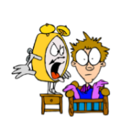 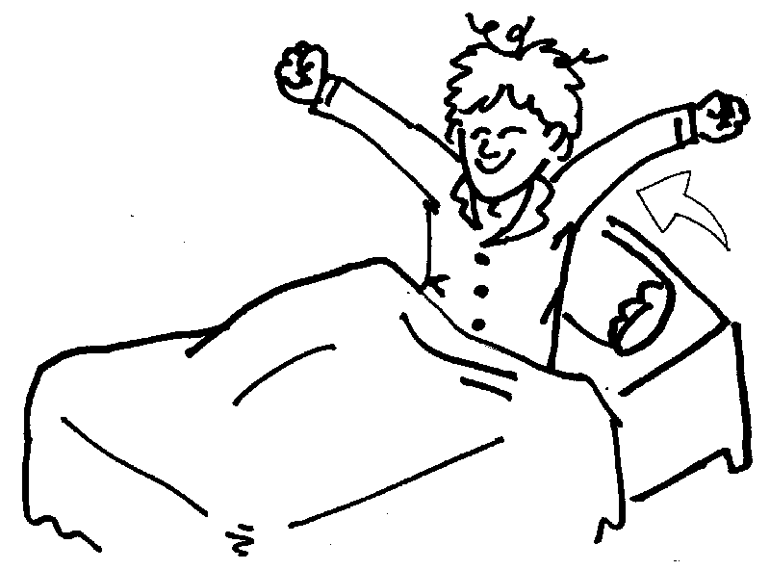 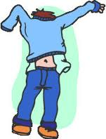

despertarse (e—ie) levantarse vestirse (e—i)

____________________ ____________________ ___________________

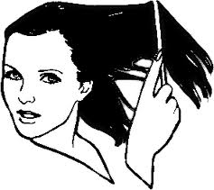 C:\Users\Erin\AppData\Local\Microsoft\Windows\Temporary Internet Files\Content.IE5\80UA0X4S\MC900089668[1].wmf 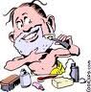

cepillarse/peinarse maquillarse afeitarse

____________________ ____________________ ___________________

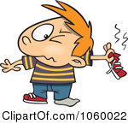 C:\Users\Erin\AppData\Local\Microsoft\Windows\Temporary Internet Files\Content.IE5\XEXT20L4\MC900232153[1].wmf C:\Users\Erin\AppData\Local\Microsoft\Windows\Temporary Internet Files\Content.IE5\XEXT20L4\MC900355899[1].wmf

quitarse bañarse secarse

____________________ ____________________ ___________________

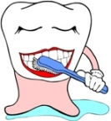 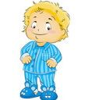 C:\Users\Erin\AppData\Local\Microsoft\Windows\Temporary Internet Files\Content.IE5\QM4169Y5\MC900358879[1].wmf

cepillarse/lavarse ponerse acostarse (o—ue)

____________________ ____________________ ___________________

Los verbos reflexivos:

**Reflexive verbs** are verbs that you do ‘to oneself’. The infinitive form of reflexive verbs always has –se at the end of the verb (levantar**se**, lavar**se**).

ex: ‘I brush my teeth’ (**Me** lavo los dientes)

‘I get (myself) up’ (**Me** levanto).

Forming reflexives are easy! Just…

1. Conjugate using regular –ar/-er/-ir endings.
2. Add the reflexive pronoun (me,te,se,nos,os,se) in front of the verb to match your subject!

|  |  |
| --- | --- |
| **me** levanto | **nos** levantamos |
| **te** levantas | **os** levantáis |
| **se** levanta | **se** levantan |

¿Cómo se dice…?

1. I wash my face. ______________________________________________________
2. You brush your teeth. ______________________________________________________
3. My brother takes a bath. ______________________________________________________
4. My parents go to bed. ______________________________________________________
5. We wake up at 6. ______________________________________________________
6. I don’t shave. ______________________________________________________