Nombre ___________________________________________ Fecha ____________________ Per ________

Ch 2.1 Más lugares en la ciudad:

|  |  |  |  |
| --- | --- | --- | --- |
| C:\Users\Erin\AppData\Local\Microsoft\Windows\Temporary Internet Files\Content.IE5\LF33FW7D\MC900434371[1].wmf | https://lh5.googleusercontent.com/-j6eA9rsFp28/SmcyJOWdFtI/AAAAAAAAJRA/UjtAHn_GZ9U/s480/fuente-.jpg | http://www.polyvore.com/cgi/img-thing?.out=jpg&size=l&tid=16818229 | http://www.mupa.com.mx/imagenes/productos/normal/21-6-mobiliario-urbano.jpg |
| La plaza | La fuente | La estatua | La banca |
| http://www.einstein.yu.edu/uploadedImages/administration/auxiliary-services/spotlight/falk-collage.jpg | http://www.cem.va.gov/CEM/images/cemphotos/826_alexandria_va.jpg | http://classroomclipart.com/images/gallery/Clipart/Europe/notre-dame-cathedral-france.jpg | https://everythingtianjin.com/services/wp-content/uploads/sites/19/2015/02/Embassy-Building-Feature-Image2-351x185.jpg |
| El centro recreativo | El cementerio | La catedral | La embajada |
| http://epspark.com/images/800/underwater-world.jpg | http://img.archiexpo.com/images_ae/photo-g/newspaper-kiosk-60904-2097269.jpg | C:\Users\Erin\AppData\Local\Microsoft\Windows\Temporary Internet Files\Content.IE5\LF33FW7D\MC900014468[1].wmf | C:\Users\Erin\AppData\Local\Microsoft\Windows\Temporary Internet Files\Content.IE5\CDC8F6Z8\MC900297985[1].wmf |
| El acuario | El quiosco | La mueblería | La fábrica |
| http://piperreport.com/wp-content/uploads/2014/08/Medicaid-Hospital-Emergency-Room-Use.jpg | http://thumbs.dreamstime.com/t/container-ship-port-vector-illustration-45963844.jpg | C:\Users\Erin\AppData\Local\Microsoft\Windows\Temporary Internet Files\Content.IE5\EZJ17Z6W\MC900089286[1].wmf | C:\Users\Erin\AppData\Local\Microsoft\Windows\Temporary Internet Files\Content.IE5\CDC8F6Z8\MC900060382[1].wmf |
| La sala de emergencia | El puerto | La parada de… | El estacionamiento |

Verbos:

|  |  |  |  |  |  |
| --- | --- | --- | --- | --- | --- |
| C:\Users\Erin\AppData\Local\Microsoft\Windows\Temporary Internet Files\Content.IE5\S5U27JRI\MC900434805[1].png | http://www.uniqueteachingresources.com/images/SchoolBusClipArt2.jpg | | http://blog.centerforautism.com/wp-content/uploads/2011/02/2011-02-18-School-Bus.jpg | | http://www.illustrationsof.com/royalty-free-lost-clipart-illustration-1047105tn.jpg |
| Parar | Subirse | | Bajarse | | Perderse |
| http://us.123rf.com/400wm/400/400/cbenjasuwan/cbenjasuwan1103/cbenjasuwan110300264/9486280-the-white-arrow-on-the-road-background.jpg | | C:\Documents and Settings\CCUSTIS\Local Settings\Temporary Internet Files\Content.IE5\F2KVJ5CH\MP900385955[1].jpg | | C:\Documents and Settings\CCUSTIS\Local Settings\Temporary Internet Files\Content.IE5\F2KVJ5CH\MP900385955[1].jpg | |
| Seguir (e🡪i) derecho/adelante | | Doblar a la izquierda | | Doblar a la derecha | |

La cuadra:

|  |  |  |
| --- | --- | --- |
| C:\Users\Erin\AppData\Local\Microsoft\Windows\Temporary Internet Files\Content.IE5\EZJ17Z6W\MC900433882[1].png | C:\Users\Erin\AppData\Local\Microsoft\Windows\Temporary Internet Files\Content.IE5\EZJ17Z6W\MC900290387[1].wmf | http://upload.wikimedia.org/wikipedia/commons/6/6d/Ponce_Chamfered_Street_Corner.jpg |
| El semáforo | El cruce | La esquina |
| http://ecx.images-amazon.com/images/I/51%2BwuXPRM8L._SL500_AA300_.png | http://www.psdgraphics.com/file/curved-road-on-white.jpg | http://farm1.staticflickr.com/96/238692637_02a6da752f_z.jpg |
| La autopista | La carretera (calle) | La avenida |
| http://www.djc.com/blogs/SeattleScape/wp-content/uploads/2009/11/sidewalk.jpg | http://t2.gstatic.com/images?q=tbn:bCYevLQ5diqxiM:http://upload.wikimedia.org/wikipedia/commons/thumb/b/b3/Zeichen_242.svg/600px-Zeichen_242.svg.png | C:\Documents and Settings\MMATTHEW\Local Settings\Temporary Internet Files\Content.IE5\MNGZU1WB\MCj04120220000[1].wmf |
| La acera | La zona peatonal | La zona verde |

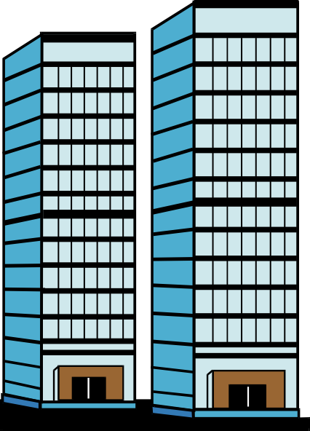

5o

3o

1o

7o

9o

8o

La planta baja

2o

4o

6o

10o

**Exprésate**:

Perdón, ¿cómo puedo llegar a___________________________?

___________________________________________________________________________________

Disculpe, ¿vamos bien para ______________________________?

___________________________________________________________________________________