Nombre ________________________________________ Fecha___________________________ per_____________

El alfabeto español:

|  |  |  |  |
| --- | --- | --- | --- |
| A *(a)* | H *(ah-chay)* | Ñ *(N-yay)* | U *(ooh)* |
| B *(bay)* | I *(ee)* | O *(oh)* | V *(vay)* |
| C *(say)* | J *(hota)* | P *(pay)* | W *(doble vay)* |
| D *(day)* | K *(kah)* | Q *(coo)* | X *(equis)* |
| E *(A)* | L *(L-A)* | R *(air-ray)* | Y *(ee griega)* |
| F *(F-A)* | M *(M-A)* | S *(S-A)* | Z *(say-tah)* |
| G *(hay)* | N *(N-A)* | T *(tay)* |  |

Los días de la semana:

|  |  |  |  |  |  |  |
| --- | --- | --- | --- | --- | --- | --- |
|  |  |  |  |  |  |  |

¿Qué día es hoy? ________________________________¿Qué fecha es hoy? ________________________________

|  |  |  |  |
| --- | --- | --- | --- |
| Las estaciones: | Los meses del año: | | |
| La primavera 🡪 |  |  |  |
| 🡪 |  | julio (7) |  |
| 🡪 |  |  | noviembre (11) |
| 🡪 | diciembre (12) |  |  |

Los colores:

 MC900084054[1] *MC900027601[1]* **

____________________ ____________________ ____________________ ___________________

  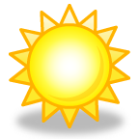 MC900326482[1]

____________________ ____________________ ____________________ ___________________

  C:\Users\Erin\AppData\Local\Microsoft\Windows\Temporary Internet Files\Content.IE5\ZSXGT2K3\MC900301302[1].wmf

____________________ ____________________ ____________________

¿Qué hora es?

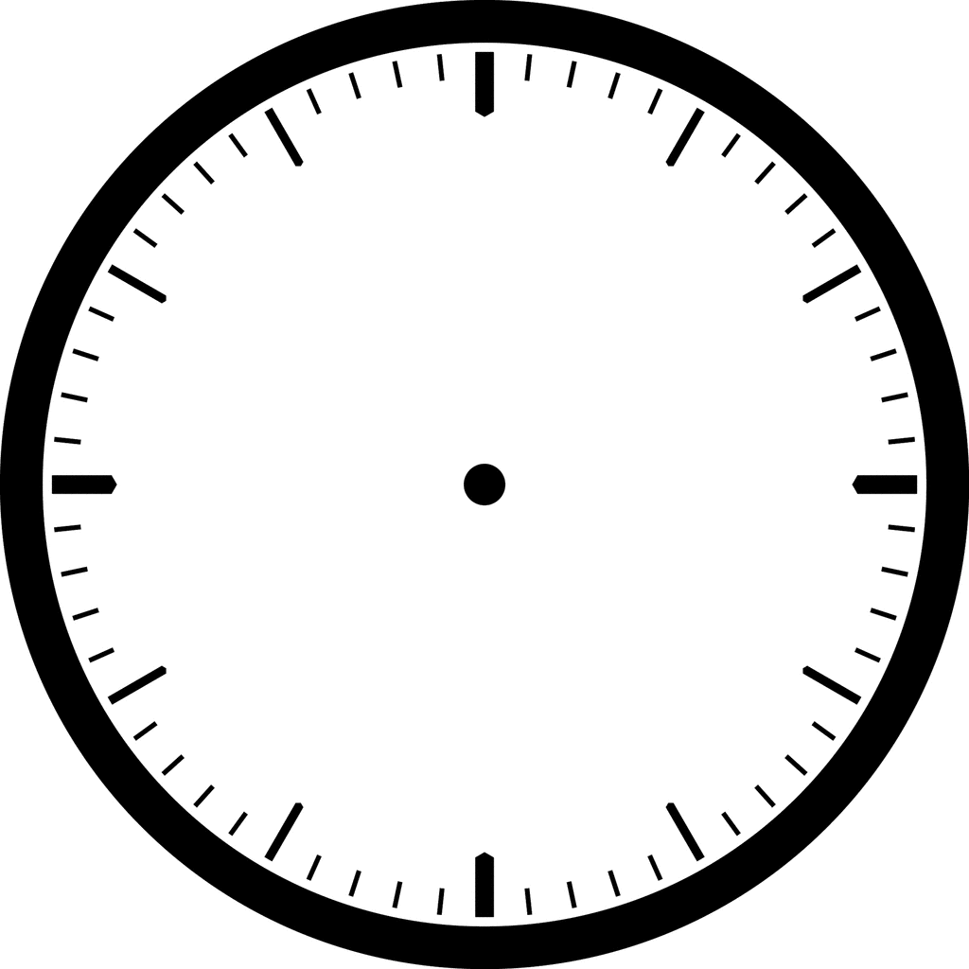

12:31 – 1:30… _____________________________ Any other time…__________________________

:01 - :30… ________________________________ :31 - :59… _______________________________

:15… ____________________________________ :30… ___________________________________

AM______________________________________ PM _____________________________________

Ejemplos:

1. 5:12_____________________________________________________________________________
2. 12:50_____________________________________________________________________________
3. 8:45_____________________________________________________________________________
4. 1:29 _____________________________________________________________________________
5. 9:30 _____________________________________________________________________________

Nombre ________________________________________ Fecha _________________________ Clase_____

Palabras interrogativas

To ask for more information than just a simple ***sí*** or ***no***, use the following question words.

|  |  |  |  |
| --- | --- | --- | --- |
| ***Question word*** | ***Plural form*** | ***Example*** | ***What’s the answer?*** |
| **¿Qué?** | **--** |  |  |
| **¿Cuál?** | **¿Cuáles?** |  |  |
| **¿Cómo?** | **--** |  |  |
| **¿ Dónde?** | **--** |  |  |
| **¿Cuándo?** | **--** |  |  |
| **¿Quién?** | **¿Quiénes?** |  |  |
| **¿Cuánto?** | **¿Cuántos?**  **¿Cuántas?** |  |  |
| **¿Por qué?** | **--** |  |  |